Thai Burrito with Peanut Sauce

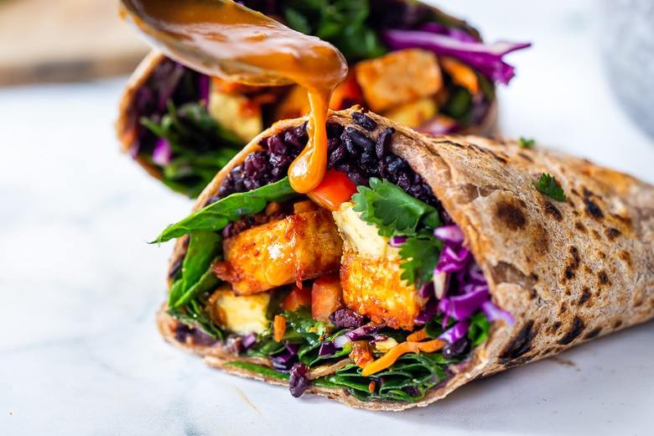

DESCRIPTION:
Delicious Thai Burritos with Peanut Sauce, baked peanut Tofu, black rice, spicy sriracha black beans and shredded crunchy veggies all wrapped up in a warm, whole wheat tortilla. Makes 4 hearty burritos

INGREDIENTS:
1/4–1/3 cup fresh orange juice (roughly 1 orange)
2 Tablespoons red curry paste
2 tablespoons olive oil
2 tablespoons sesame oil
2 tablespoons maple syrup, honey, agave or brown sugar
1 tablespoon rice vinegar
1/2 cup peanut butter (or sub almond butter!)
1/2 teaspoon salt
Burrito Ingredients: (makes 4 large)
16-ounce block tofu (extra firm), cut into 12 strips, see photos.
1–2 cups cooked rice- brown rice, black rice, etc.
14-ounce can refried black beans, seasoned with chile paste or sriracha.
1 cup shredded cabbage (or finely sliced)
1 cup shredded carrots (or match stick)
1 red bell pepper, thinly sliced
1 large avocado, sliced
1/2 cup cilantro leaves or Thai basil
4 extra -large, whole grain tortillas, warmed until pliable.
optional: crushed roasted peanuts, or Peanut Chili Crunch
Cook Mode Prevent your screen from going dark

INSTRUCTIONS:
Preheat oven to 425.
Make the marinade, either blending in a blender or whisking in a bowl ( if whisking, add the peanut butter last, adding a little at a time to incorporate).
TOFU PREP: Blot the tofu gently, and cut into 6 slices (see photo), then cut each slice into two, to make 12 strips. Place on a parchment-lined sheet pan. Sprinkle lightly with salt. Brush all sides liberally with the peanut sauce, spooning a little extra over the tops. Bake 25-30 minutes. Save the remaining sauce for the burritos.
COOK RICE: The fastest way to make rice is using the pasta method. Boil 1/2 cup rice in 4-5 cups salted water, uncovered, drain when tender, using a strainer, letting stand in the strainer 5 mins. Fluff.
Prep the veggies and herbs: cut and place them on a tray or plate with the peanut sauce.
Heat the refried beans, whisking in 2-4 tablespoons water with a fork to loosen them. Add a spoonful of garlic chili paste, Sambal Olek, or a squirt of sriracha to taste, to pep them up a bit. Keep them warm.
Tortillas: Right before assembling the burritos, warm the tortillas to make them soft and pliable. If you have a gas stove, use tongs, place directly on the gas grate, over medium flame, turning often with tongs. Otherwise, place in a single layer in the oven on the rack until soft and pliable. Wrap in a kitchen towel to keep warm.
Assemble: Spoon some of the warm beans onto the tortilla creating a base, add rice, then tofu and veggies and herbs. Spoon some peanut sauce over top, and optional peanuts or peanut chili crunch, and wrap up tightly. ***I’ve found it easiest to eat with foil wrapped around the bottom half to keep these big boys all together

NUTRITION:
Serving Size:
Calories: 603
Sugar: 24.4 g
Sodium: 1685.1 mg
Fat: 31.4 g
Saturated Fat: 4.8 g
Carbohydrates: 64.9 g
Fiber: 12.8 g
Protein: 20.5 g
Cholesterol: 0 mg

